Useful Links to accompany the Scots Language Award course videos

The following links refer to resources used, demonstrated or referred to within each video, so some links may be repeated.

Scots Language Award Video 1: Useful links 2
Scots Language Award Video 2: Useful links 2
Scots Language Award Video 3: Useful links 3
Scots Language Award Video 4: Useful links 3
Scots Language Award Video 6: Useful links 5
Scots Language Award Video 7: Useful links 6
Scots Language Award Video 8: Useful links 6

Scots Language Award Video 1: Useful links

The Origins of Scots video (in English and in Scots)

The History of Scots video and learning resources

Lennie Pennie on Tik Tok (warning, may have mature content)

Dictionary of the Scots Language

http://www.scotslanguage.com/learning

Scots Language Award Video 2: Useful links

The History of Scots video and learning resources

History of the Scots Language from the Scots Language Centre – see the left-hand-side for links to the timelines.

Scotticisms resource from the National Library of Scotland’s ‘The Scottish Enlightenment’ site

Paulo Nutini – A Man’s A man

Paulo Nutini – Auld Lang Syne (with interview)

Scots Language Award Video 3: Useful links

The Scots Language Centre’s ‘Guide to a map of Scotland in Scots’ includes a useful table demonstrating the origin of various place names.

ASL have a Place-Names of Scotland resource.

The online Dictionary of the Scots Language is useful for determining the origin of a word.

The Scots blog, Mak Forrit, has a table of Scots an ither leids, with audio.

Scots Language Award Video 4: Useful links

Education Scotland's ‘Features of Scots’ resource is designed for teachers. It is invaluable for looking at Scots grammar.
The Scots Language Centre’s Support and Guidance for writing document has a useful grammar section.
The Scots Syntax Atlas is useful for demonstrating variations of Scots grammar around Scotland.
The Scots Corpus is a searchable database of over 1000 texts containing Scots.

Scots Language Award Video 5: Useful links

Texts referred to in Video 5:
- Buddha Da by Anne Donovan

The following texts referred to in Video 5 are freely available for reading, listening, viewing and/or download:

- The Abdication of Mary Queen of Scots by Gerda Stevenson

- THE MANNIE & Ither Stories by James Robertson

- Bessie Dunlop, The Witch O Dalry by John Hodgart

- ‘Old Tongue’ by Jackie Kay (part of BBC’s ‘Blethering Scots’)

- Scots Radio

- Oor Wee Podcast by Susi Briggs and Alan McClure

- Bella Caledonia (with various news articles in Scots by Alistair Heather)

- A Nappie Lassie Blethers tae a Fritter by Martin Travers (short film)

- The Twa Chrisses by Morna Young (narrated story with transcript)

- Music by Iona Fyfe and Christy Scott
The Cauld: The Cauld - Iona Fyfe (Official Video)

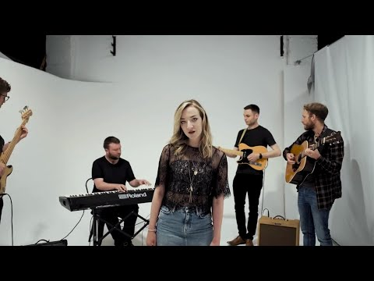

Scots Language Award Video 6: Useful links

BBC Bitesize Literary techniques videos (defining terms such as word choice, metaphor, simile, personification...)

The Twa Chrisses by Morna Young (narrated story with transcript)

Reading exercises from the Scots Language Centre at www.scotslanguage.com/learning

Scots Language Award Video 7: Useful links

Scots Radio

Blethering Scots

Lennie Pennie on Tik Tok (warning, may have mature content)

Scots Wikipedia

Write Times and Write Times 2 (Examples of writing, including Scots writing, from SQA English folios at all levels)

Iona Fyfe content (including song lyrics) at Scots Language Centre

TV reviews from The Guardian

Scots Language Award Video 8: Useful links

Education Scotland's 100 Key Words in Scots resource:

Scots language Dictionary for schools app (Apple)

Scots language Dictionary for schools app (Android)

Dictionaries of the Scots Language: https://dsl.ac.uk/

‘All that Glisters’ by Anne Donovan, from the SCOTS Corpus

What is a pronoun? From BBC Bitesize

Count nouns and uncountable nouns from BBC Learning

